SendBird Assignment

Assessments:-

● << Assessment 1 : 10 points>>

Provide screenshot of “Group channels” page and “Users” page of your dashboard

which shows result of step 7 and step 8.

Ans -

Screenshot for step 7- Here, 3 users are created u1, u2, u3.

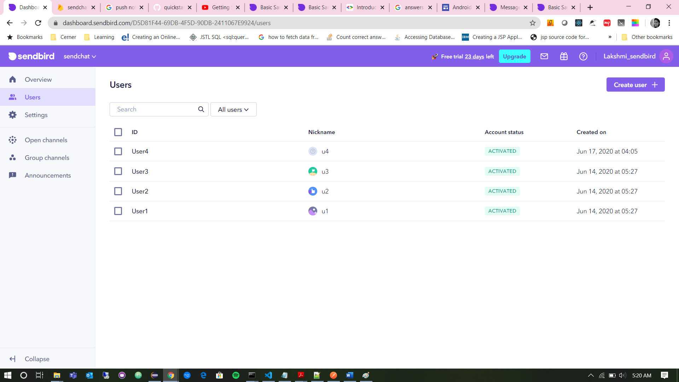

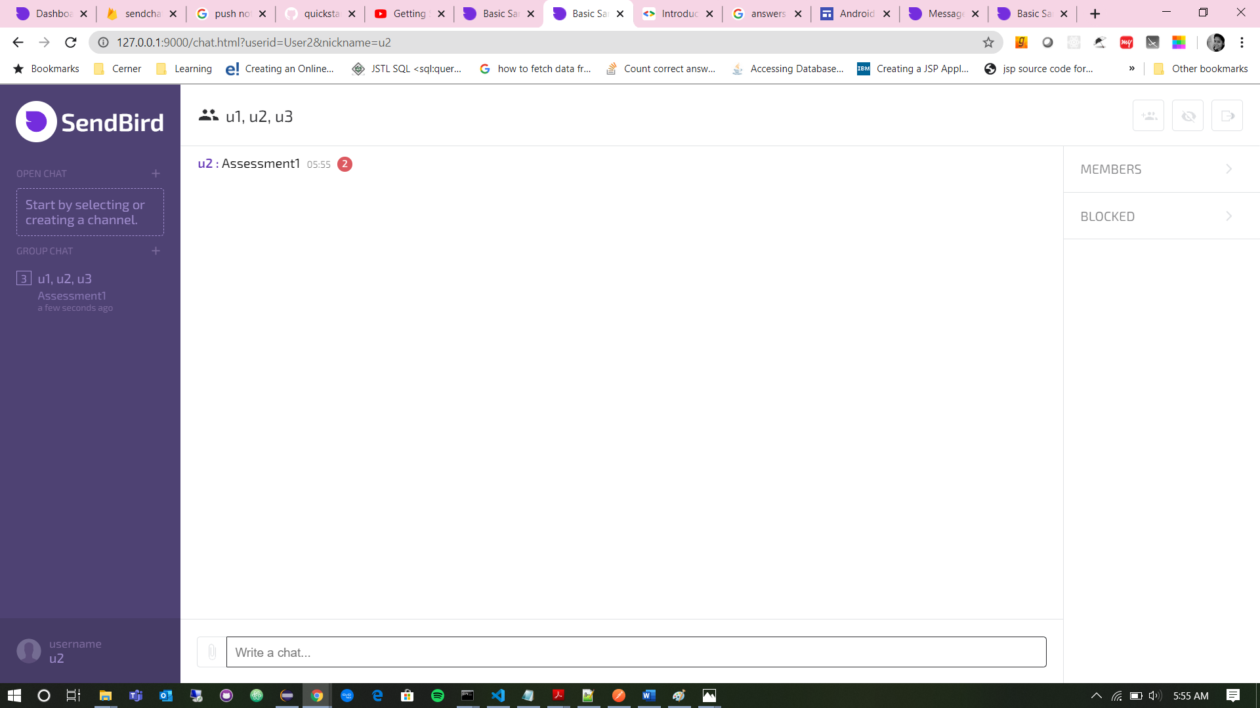

● << Assessment 2 : 20 points>>

Provide screenshot(emulator case) or photo(device case) of sample app which is

displaying “Group channels” list which shows result of step 11 and step 12.

Ans –

Custom type is set to “c1”. And below screenshot shows the list while creating group channel. All the users have custom type as prefix.

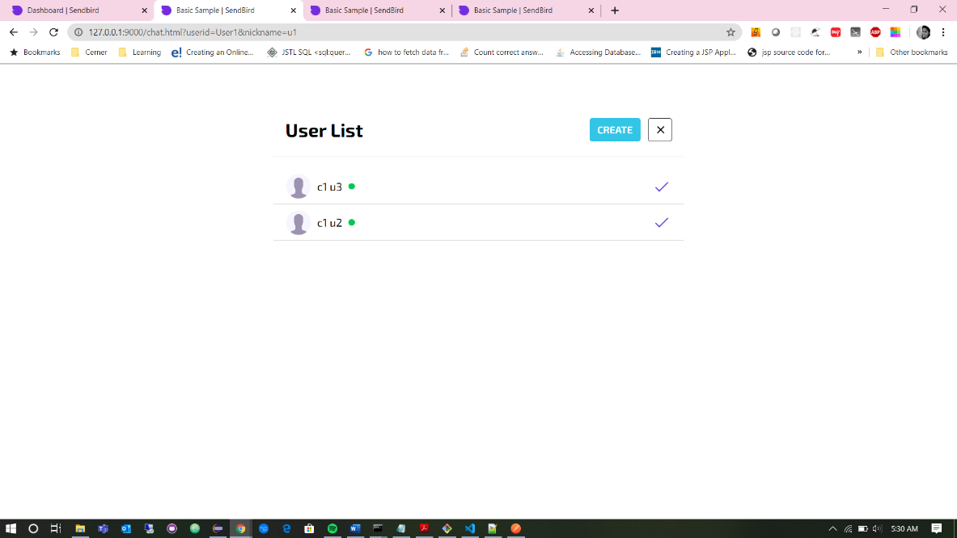

Below screenshot shows group channel that contains channel title as custom type joined with nickname.

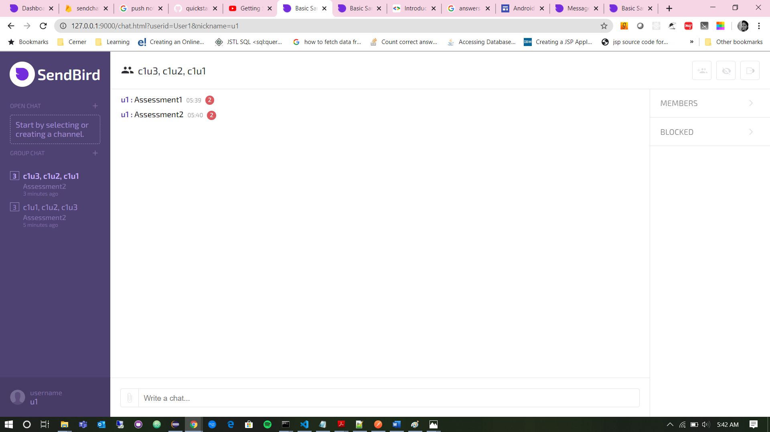

● << Assessment 3 : 30 points>>

Provide screenshot(emulator case) or photo(device case) of sample app which is

displaying “Group channels” list which shows result of step 14.

Ans – Here, group channels list will show only those group channels which has custom type in it.



● << Assessment 4 : 40 points>>

Provide screenshot(emulator case) or photo(device case) of sample app which is

displaying notification of message received from “Group channels” list which shows

result of step 16.

Ans –

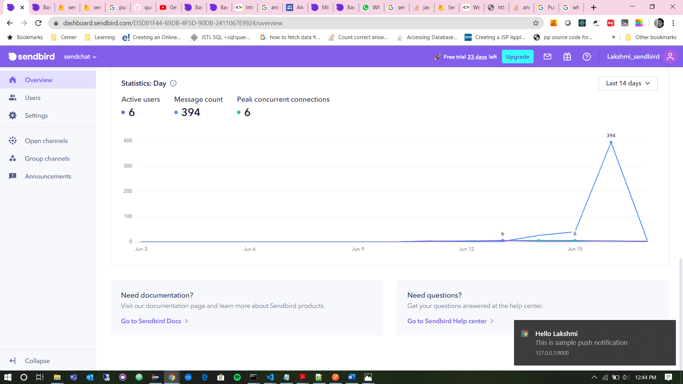

Bonus:-

1. In instructions above, at step 9 and step 12, we sent a message after creating new

channel. If we don’t do this, the created channel will not be displayed. Try to make the best guess of the reason why and provide.

Ans – Here, all the group channels which does not contain any messages will be excluded from the list which is shown on the left side of the page. The reason behind that is there is a property for group channel list query which decides whether to include channel which are empty or not.

2. In above Bonus 1, we can make the channels without message are listed as well. Please explain how we can make it happen? (What should we change in my group channel list query?) ( 10 points )

Ans – Group channel list query defines several properties. One of which is *‘includeEmpty’* property. ‘*includeEmpty’* is a Boolean field. Toggling this property can exclude or include group channels in the list. If ‘*includeEmpty’* is true then that implies channels without messages will be displayed in the left list as well. Here, is_distinct property can be used through platform API depending on requirement.

3. In the step 16, we can do the same thing(showing notification) in the chatting screen as well not only for “Group channels” list screen. In that case, what and why should we be careful on implementing it? ( 15 points )

Ans – There are two ways that the message is going to arrive. First, if the web page isn’t visible or the browser is closed, the message will be received in service worker file. Here, we can show a notification. If the user currently has web page open, the push message will be received inside your web page. Here, we can decide how we want to show that an event has just occurred. We can have our code snippet like messaging.onMessage(function(payLoad)){

// Here we can either show notification or just get it received in the chat instead of showing notification.

});

While implementing we need to take care of several factors:-

* For Chrome to route FCM messages to the correct service worker, it needs to know the Sender ID. Make sure you supply correct gcm_sender_id property to your app's manifest.json file.
* Special care must be taken to ensure that the service account JSON file is not exposed to external parties.

4. If you used “Postman( https://www.getpostman.com ) application or “curl” before for making http request with, you can do step 7, step 8 and step 9 with our platform API instead of mobile apps or from dashboard. (30 points)

○ Please read carefully our platform API quick guide

○ Provide screenshot which shows http request(with body, if there is, or request

header) and response from our chat server for the items below in the reference

of our platform API docs

***a***. Create a new user with nickname “u4”.

***b***. Create a new channel for user “u4” and “u1”with custom type value “b4”

***c***. Send a text message “Bonus4” to above created channel.

Ans – a. Below screenshot shows creation of user “u4”.

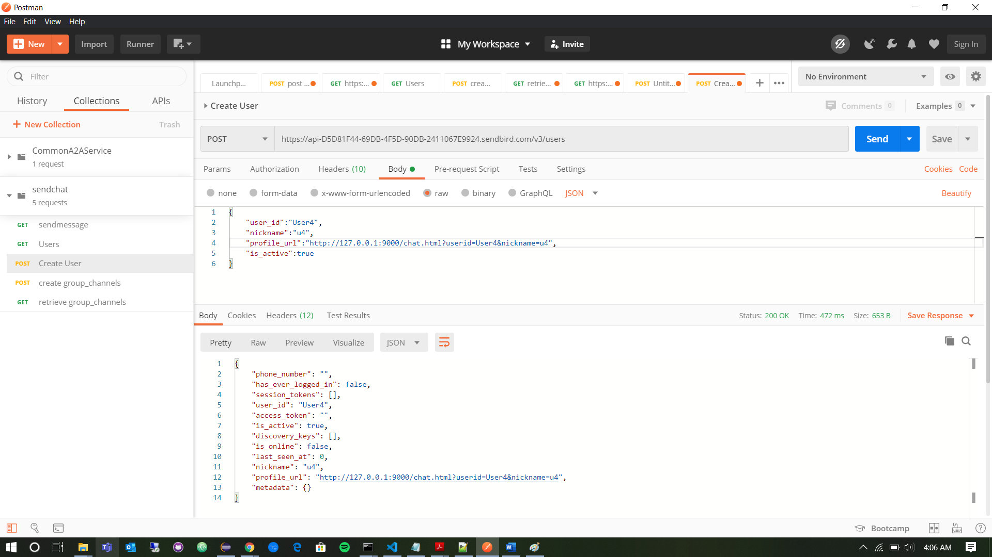

1. Screenshot showing channel creation for user “u4” and “u1”.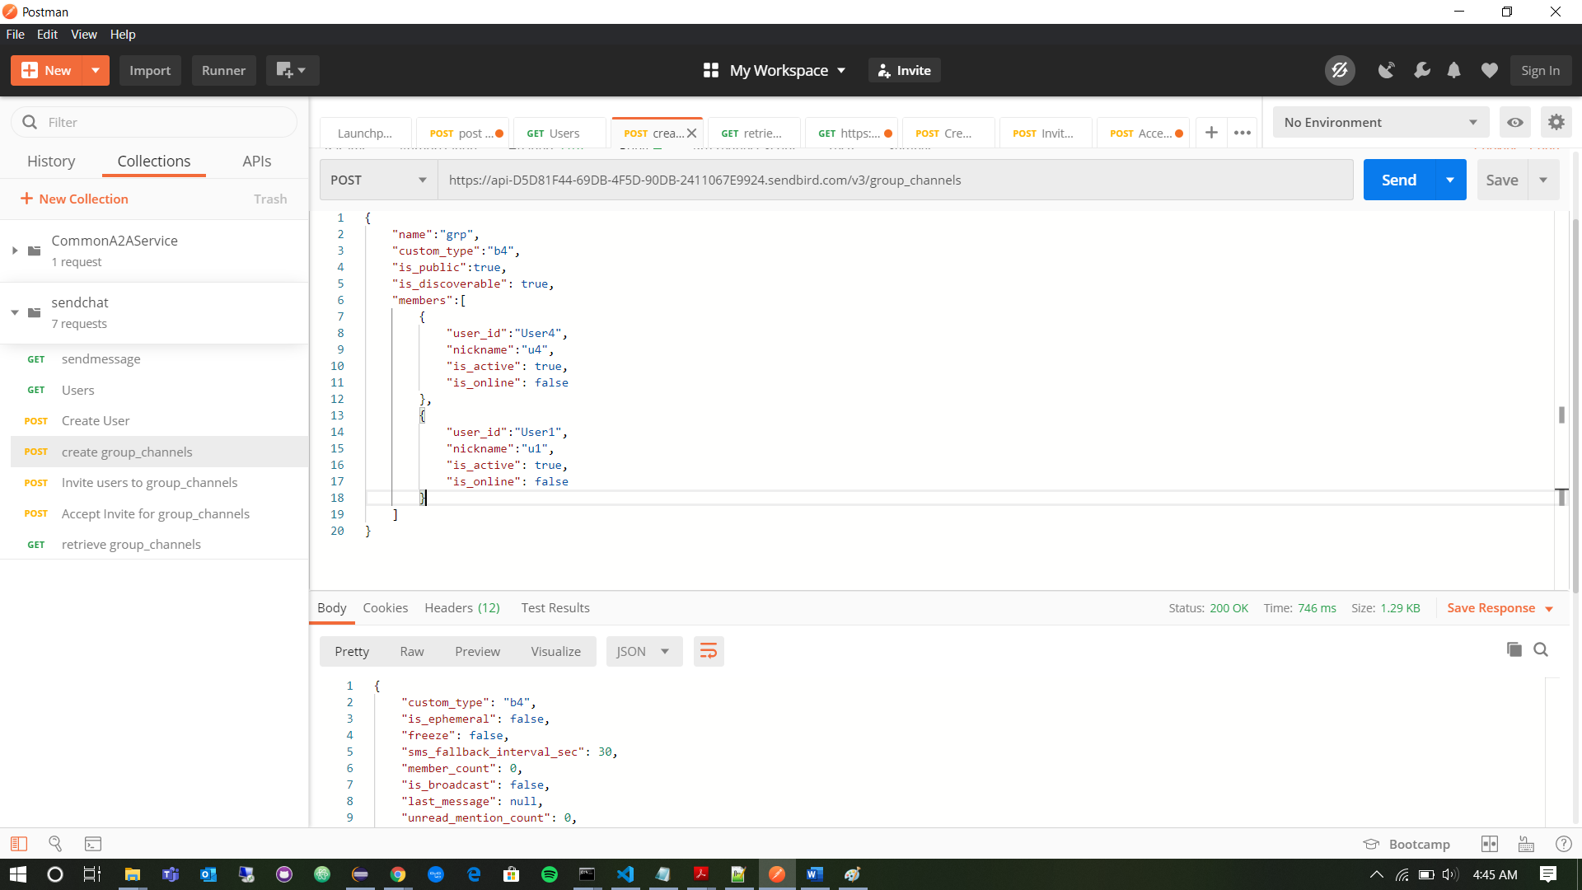
   1. Below screenshot shows how a text message “Bonus4” is sent to above created channel.

